**Assisted Practice: 1.1 Environmental Setup**

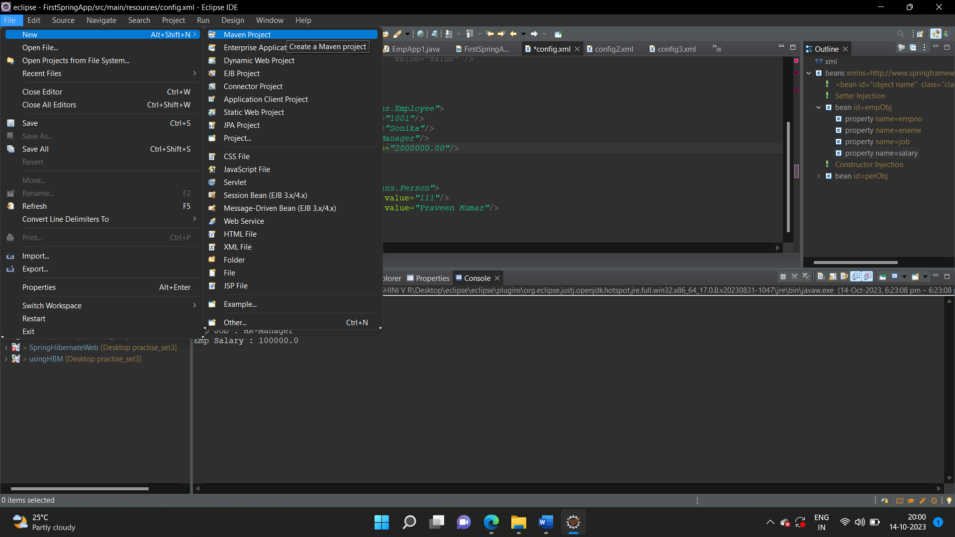

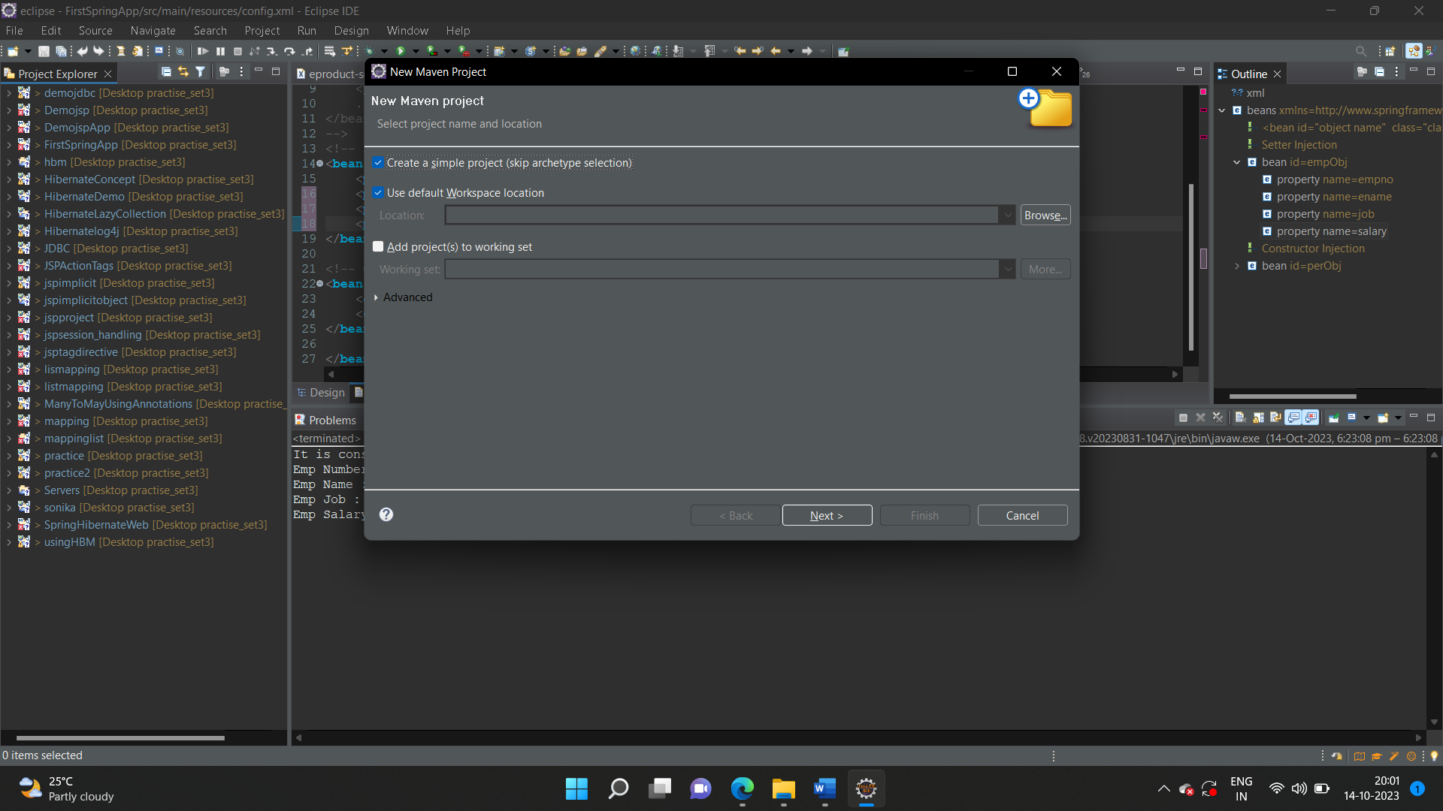

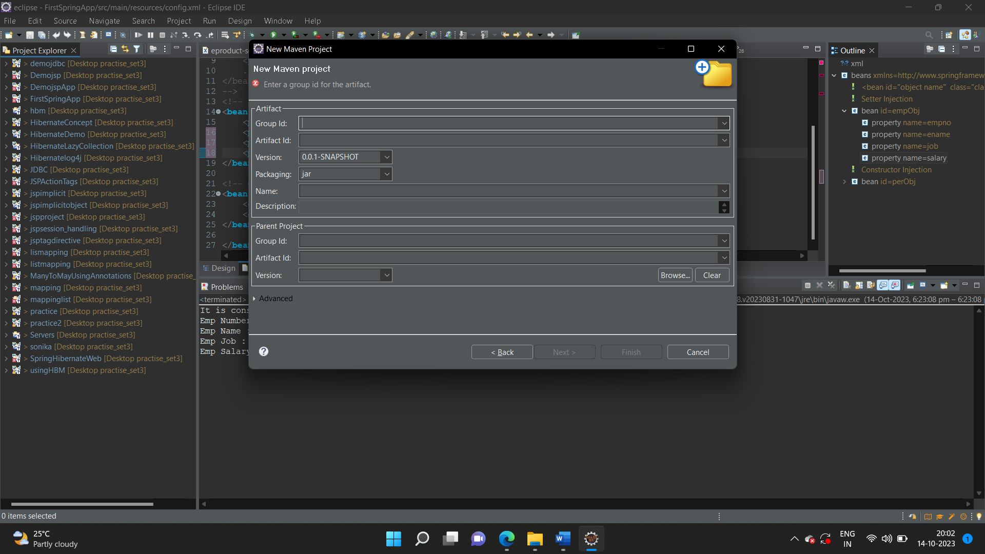

pom.xml

<project xmlns="http://maven.apache.org/POM/4.0.0" xmlns:xsi="http://www.w3.org/2001/XMLSchema-instance" xsi:schemaLocation="http://maven.apache.org/POM/4.0.0 https://maven.apache.org/xsd/maven-4.0.0.xsd">

<modelVersion>4.0.0</modelVersion>

<groupId>coms</groupId>

<artifactId>FirstSpringApp</artifactId>

<version>0.0.1-SNAPSHOT</version>

<dependencies>

<!-- https://mvnrepository.com/artifact/org.springframework/spring-core -->

<dependency>

<groupId>org.springframework</groupId>

<artifactId>spring-core</artifactId>

<version>5.3.27</version>

</dependency>

<!-- https://mvnrepository.com/artifact/org.springframework/spring-context -->

<dependency>

<groupId>org.springframework</groupId>

<artifactId>spring-context</artifactId>

<version>5.3.27</version>

</dependency>

</dependencies>

</project>

Creation of bean class

package com.beans;

public class Employee {

private int empno;

private String ename;

private String job;

private float salary;

public int getEmpno() {

return empno;

}

public void setEmpno(int empno) {

//System.out.println("It empno");

this.empno = empno;

}

public String getEname() {

return ename;

}

public void setEname(String ename) {

this.ename = ename;

}

public String getJob() {

return job;

}

public void setJob(String job) {

this.job = job;

}

public float getSalary() {

return salary;

}

public void setSalary(float salary) {

this.salary = salary;

}

}

Creation of class

package com.apps;

import org.springframework.beans.factory.BeanFactory;

import org.springframework.beans.factory.xml.~~XmlBeanFactory~~;

import org.springframework.core.io.ClassPathResource;

import org.springframework.core.io.Resource;

import com.beans.Employee;

public class EmpApp1 {

public static void main(String[] args) {

Resource rs = new ClassPathResource("config.xml");

BeanFactory fact = new ~~XmlBeanFactory~~(rs);

Employee emp = (Employee)fact.getBean("empObj");

System.***out***.println("Emp Number : " + emp.getEmpno());

System.***out***.println("Emp Name : " + emp.getEname());

System.***out***.println("Emp Job : " + emp.getJob());

System.***out***.println("Emp Salary : " + emp.getSalary());

}

}

Creation of xml file

<?**xml** version=*"1.0"* encoding=*"UTF-8"*?>

<**beans** xmlns = *"http://www.springframework.org/schema/beans"*

xmlns:xsi = *"http://www.w3.org/2001/XMLSchema-instance"*

xsi:schemaLocation = *"http://www.springframework.org/schema/beans*

*http://www.springframework.org/schema/beans/spring-beans-3.0.xsd"*>

<!--

<bean id="object name" class="classname with package">

<property name="variable name" value="value" />

.....................

</bean>

-->

<!-- Setter Injection -->

<**bean** id=*"empObj"* class=*"com.beans.Employee"*>

<**property** name=*"empno"* value=*"1001"*/>

<**property** name=*"ename"* value=*"Sonika"*/>

<**property** name=*"job"* value=*"Manager"*/>

<**property** name=*"salary"* value=*"2000000.00"*/>

</**bean**>

</**beans**>